|  |  |
| --- | --- |
| **TEAM ID** | **PNT2022TMID45918** |
| **PROJECT NAME** | **:IOT Based Smart Crop Protection System For Agriculture** |

**STEP 1:Go to the ibm cloud**

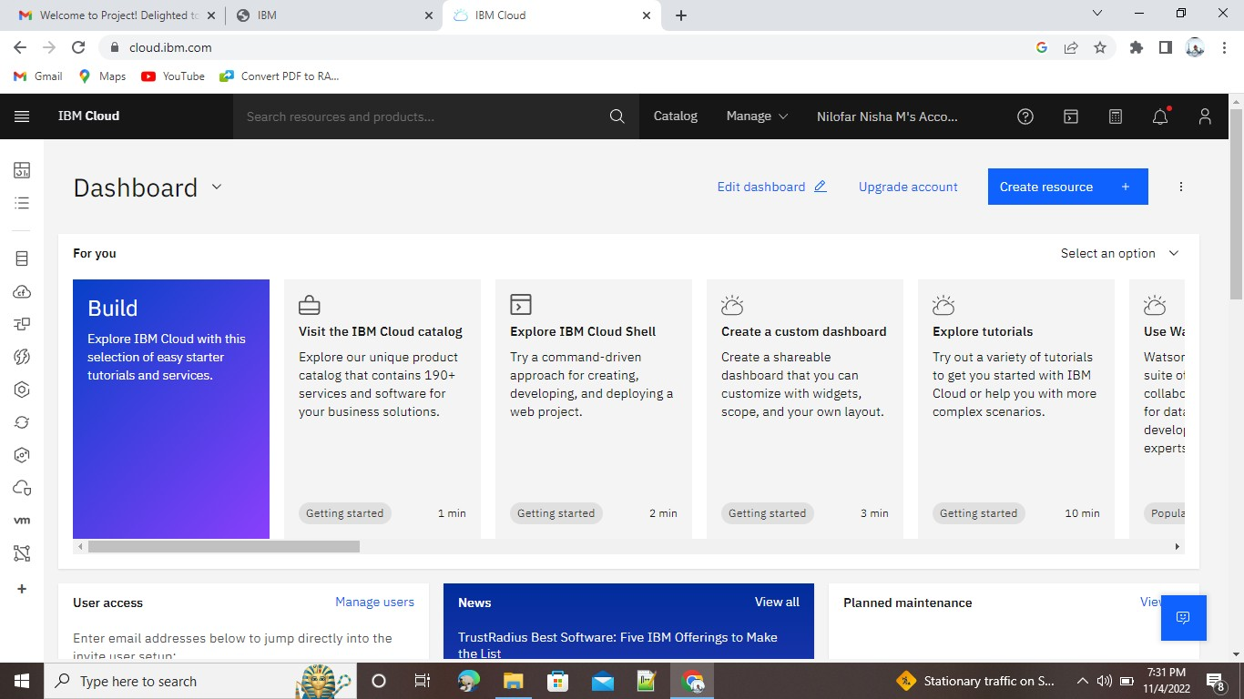

**STEP 2:** Click the catlog and click resource list and open the services

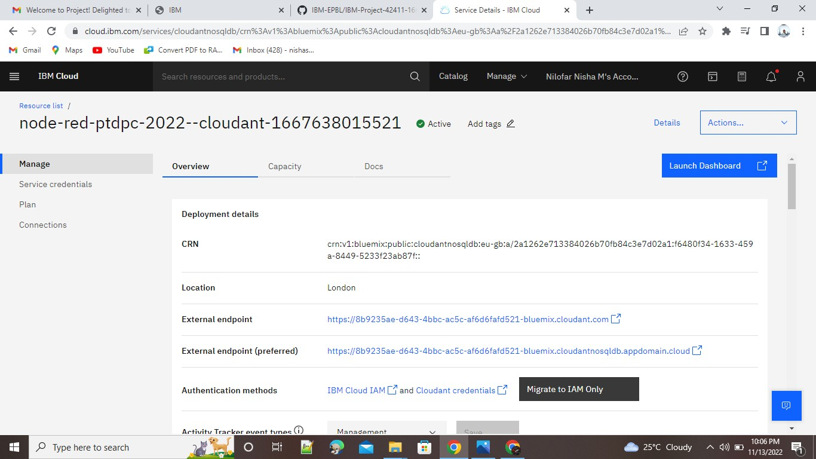

**STEP 4:** Go to launch dashboard and create document

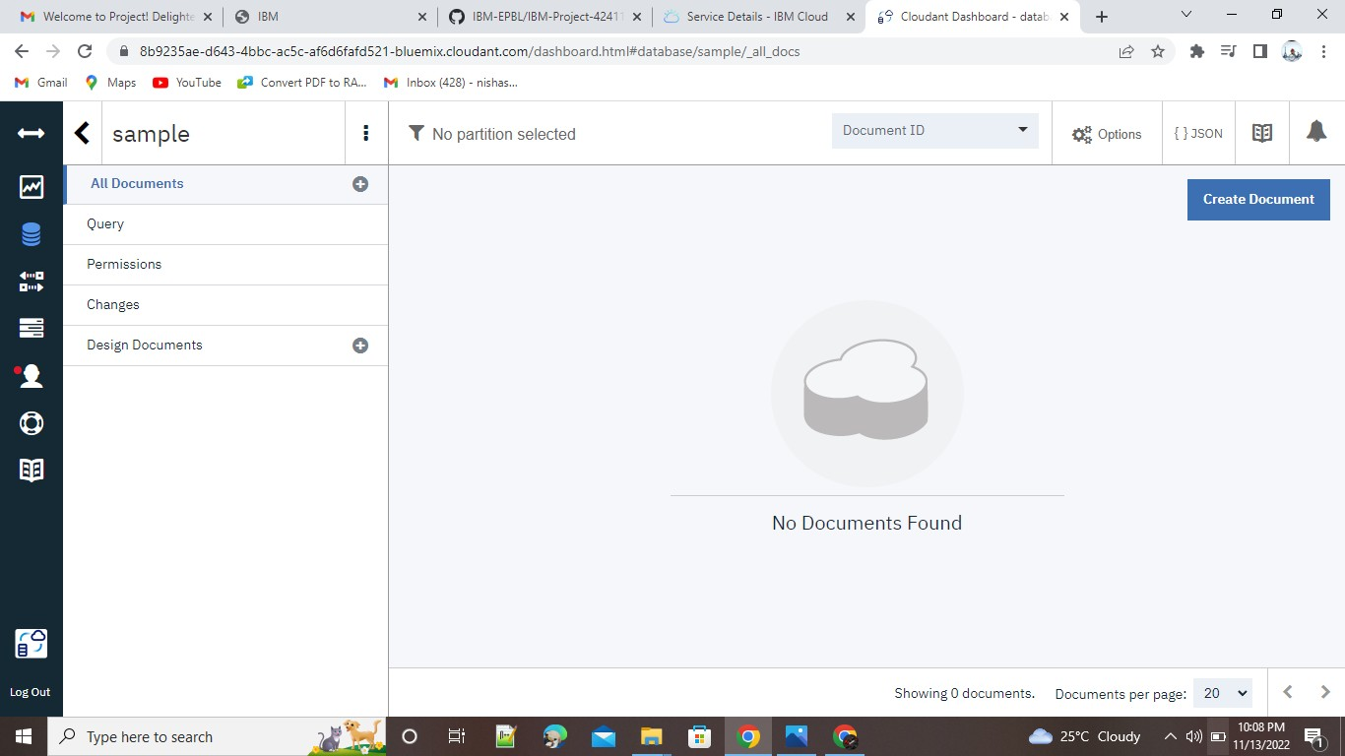

**STEP 5:** create document

